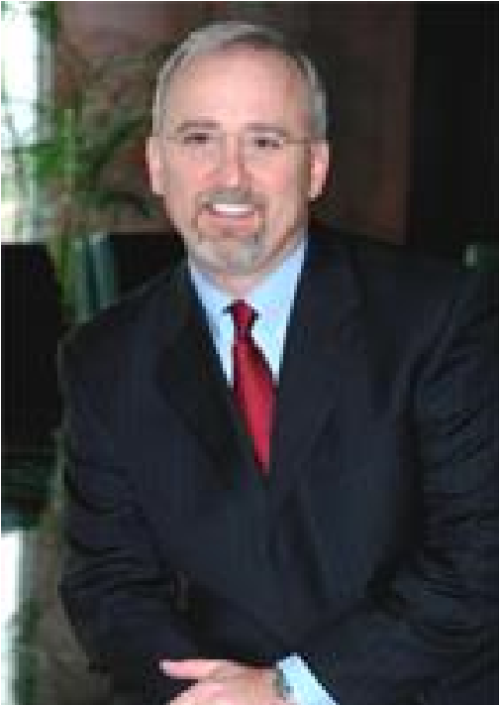
www.jhkmlaw.com
John G. Sinodis
Chairman and Managing Partner
Jennings Haug Keleher LcLeod, LLP
2800 North Central Avenue, Suite 1800
Phoenix, AZ 85004

Phone: (602) 234-7834
Fax: (602)-277-5595
Email: jgs@jhkmlaw.com

Mr. Sinodis has served as managing partner for the firm since 1999 and is the Chairman of the firm's executive committee. His practice emphasizes the representation of equipment lessors and funding sources in all aspects of equipment leasing including litigation, documentation, insolvency, and transactional matters. Besides representing equipment lessors and funding sources,
Mr. Sinodis represents financial institutions and asset-based lenders in the areas of commercial litigation, secured transactions, asset recovery, loan restructure and business litigation.

In addition to his commercial litigation practice, Mr. Sinodis is a trained mediator having received his training from the Straus Institute for Dispute Resolution at Pepperdine University School of Law.

Mr. Sinodis is an active member of the Equipment Leasing and Finance Association (ELFA) and the National Equipment Finance Association (NEFA). Prior to joining the firm, Mr. Sinodis served as the president of General Leasing Co. and is presently a member of its board of directors.

Mr. Sinodis is a graduate of Arizona State University (B.S. 1982 and J.D. 1985), is admitted in Arizona and California bars, and has earned the AV Rating with Martindale Hubbell®.
Honors and Awards
• Selected for inclusion in the Southwest Super Lawyers® lists Business Litigation (2007-2009, 2011, 2014)

Professional Associations and Memberships
- State Bar of Arizona
- State Bar of California
- Maricopa County Bar Association
- ABA - Section Membership: Law Practice Management
- ABA - Section Membership: Business Law
- Equipment Leasing and Finance Association
- National Equipment Finance Association, Member
- LEAN: Lease Enforcement Attorney Network, Member

Published Works
- UCC Article 9 Changes: A Rose by Any Other Name Would Not Smell as Sweet, NEFA Newsline page 17 (Jul/Aug. 2013)
- Co-author with Chris Stovall, Lessor More Protected: UCC Article 2A Analysis Strengthens Resistance to Common Lessee Collection Defenses, The Monitor (Jan/Feb. 2012)
- Co-author with Chris Stovall, The UCC's Public Policy Favors the Lessor, Come Hell or High Water, Lease Enforcement Attorney Network (Jan. 2012)
- Lending in Indian Country - Understanding Important Issues, co-author, Monitor, Vol.38, No.7, Conference Issue (2011)
- Co-author, What Questions should Human Resource Professionals be Asking?, NEFA Newsline (Fall 2008)
- Community Property Laws can Affect your Lease Transaction, UAEL Newsline, Vol.34, No.4 (Fall 2007)

