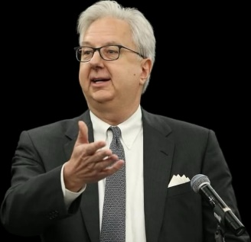**HOSTO CARDIS**

**Law Firm**

**Bryan E. Hosto**

[**bhosto@hosto.com**](mailto:bhosto@hosto.com)

**(501) 320-0201**

Bryan Hosto founded Hosto Law Firm in 1989, and later named Hosto & Buchan, PLLC from 1995 to 2024 when the name changed to Hosto & Cardis, PLLC.

Bryan earned his Juris Doctorate degree from the Bowen School of Law in Little Rock, Arkansas. He obtained his undergraduate degree in Business from the University of Arkansas at Little Rock, and in 2022 was named “Distinguished Alumnus” of the UA-Little Rock School of Business. He currently serves as Chairman of the UA Little Rock School of Business Advisory Board.

Bryan has served as President of the Arkansas Board of Make-A-Wish, where he was active in raising funds and granting wishes to children with life threatening illnesses. He served as President of Juvenile Diabetes Research Fund (JDRF) in Arkansas and also served for six years on the Board of Trustees of Pulaski Academy.

Bryan is active in promoting and improving Downtown Little Rock and currently serves on the Board of Directors of “Fifty for the Future”.

Bryan was a founding investment committee member of “Fund for Arkansas Future,” the first Angel Capital fund in Arkansas, which was central to funding and advising many successful startup companies. He is a founder of the Arkansas Angel Alliance which also promotes startup investing. He serves on the board of several fast-growing Arkansas companies.

Bryan is a member of the National Creditors Bar Association, the Arkansas and Tennessee Creditors Bar Associations, the Arkansas Bar Association, the Tennessee Bar Association, the Pulaski County, Arkansas Bar Association, and he is a Certified member of the Receivables Management Association, Inc. (RMAi).